Data Science Project Training Report

on

Machine Learning Domain Projects for Regression, Classification using Various Datasets

BACHELOR OF TECHNOLOGY

Session 2024-25
in

Computer Engineering

By:
Devansh Vashistha
2300320150022
Shambhavi Chaurasia
2300320150052
Srishti Srivastava
2300320150057

Dr. Shelley Gupta

Associate Professor

DEPARTMENT OF INFORMATION TECHNOLOGY

ABES ENGINEERING COLLEGE, GHAZIABAD
 |  | 
AFFILIATED TO
DR. A.P.J. ABDUL KALAM TECHNICAL UNIVERSITY, U.P., LUCKNOW
(Formerly UPTU)

Student’s Declaration

I / We hereby declare that the work being presented in this report entitled Online Payment Fraud Detection using Machine Learning – Python is an authentic record of my / our own work carried out under the supervision of Dr. Shelley Gupta, Associate Professor, Information Technology.

Date: 09-12-2024

Signature of student
Department: Computer Engineering

This is to certify that the above statement made by the candidate(s) is correct to the best of my knowledge.

Signature of HOD Signature of Teacher
Prof. (Dr.) Amrita Jyoti Dr. Shelley Gupta
Information Technology Associate Professor
Information Technology

Date: ..........................

Table of Contents

S. No. | Contents | Page No.
1 | Student’s Declaration | i
2 | Abstract | 1
3 | Introduction | 2-4
4 | Literature review | 5-8
5 | Implementation | 9-12
6 | Data Visualization | 13-16
10 | Prediction models | 17-19
11 | Conclusion | 20
12 | Future work | 21-23
14 | References | 24-25

Abstract

Online fraud is a growing concern as digital transactions proliferate across the globe. Fraud detection systems must adapt to evolving tactics, making traditional rule-based systems insufficient. This report delves into the use of machine learning (ML) to address these challenges, leveraging data-driven approaches for accuracy and efficiency. ML algorithms excel in detecting anomalies and patterns that signal fraudulent activity, adapting dynamically to new threats. Supervised learning, unsupervised learning, and deep learning methods are explored for their potential to enhance fraud detection systems. Key challenges include class imbalance, real-time processing, and reducing false positive rates without compromising sensitivity. The report outlines methodologies including data preprocessing, feature engineering, and model evaluation. Comparative analysis of models highlights their strengths and limitations in detecting fraud. Deployment strategies emphasize real-time integration, scalability, and continuous learning to keep pace with emerging threats. Results demonstrate the effectiveness of ML in improving detection accuracy and efficiency. While challenges persist, such as adversarial attacks and evolving fraud tactics, this study underscores the transformative potential of ML in safeguarding online systems. Future work aims to refine hybrid models and incorporate advanced techniques to further enhance the robustness of fraud detection systems in dynamic environments.

Keywords: Online fraud, fraud detection, machine learning, supervised learning, unsupervised learning, deep learning, anomaly detection, real-time processing, feature engineering, model evaluation, scalability, adversarial attacks.

Introduction

Online fraud encompasses a wide range of malicious activities, including identity theft, phishing, account takeovers, and fraudulent transactions. Traditional rule-based systems, while effective in some scenarios, often struggle to adapt to evolving fraud tactics. Machine learning (ML) offers a dynamic and adaptive approach by learning patterns and anomalies from historical data.

Overview:

This report examines the application of machine learning to detect and mitigate online fraud. With the rise of digital transactions, fraudsters employ increasingly sophisticated methods, challenging traditional detection systems. Machine learning offers a dynamic and scalable solution by learning from historical data to identify patterns and anomalies that indicate fraudulent activity. Key areas explored include data preprocessing, feature engineering, and the implementation of supervised, unsupervised, and deep learning models. The study provides a comparative analysis of these approaches, highlights the challenges of class imbalance and real-time decision-making, and proposes strategies for effective deployment. The findings demonstrate the potential of ML in enhancing fraud detection accuracy while minimizing false positives. This report serves as a comprehensive guide for implementing ML-based solutions to safeguard online transactions, emphasizing adaptability to evolving fraud tactics and the need for continuous learning systems.

Aim:

The primary aim of the project is to develop a machine learning model that can accurately detect fraudulent online transactions. This will help mitigate the financial and reputational losses caused by fraud, enhance the security of digital payment systems, and support decision-making processes in real-time fraud prevention and risk management.

Objectives:

- To develop an ML-based system capable of detecting fraudulent activities with high precision and recall.
- To minimize false positives while ensuring low latency for real-time decision-making.
- To evaluate and compare the performance of various ML models for fraud detection.

Machine Learning -:
- Supervised Learning: Logistic Regression, Decision Trees, Random Forest, Gradient Boosting (XGBoost, LightGBM).
- Unsupervised Learning: Clustering techniques (K-Means, DBSCAN) for anomaly detection.
- Deep Learning: Neural networks (DNNs, Autoencoders) for advanced pattern recognition.

Literature review

The growing body of research on online fraud detection highlights the transition from traditional rule-based systems to machine learning-based approaches.
- Rule-Based Systems: Early fraud detection relied heavily on predefined rules and thresholds, such as transaction limits and geolocation constraints. While effective for known patterns, these systems lacked adaptability to new fraud tactics and resulted in high false positive rates.
- Supervised Machine Learning: Recent studies explore the application of supervised learning models like Logistic Regression, Random Forest, and Gradient Boosting. According to [Author, Year], these models demonstrate high accuracy in identifying fraudulent transactions when sufficient labeled data is available.
- Unsupervised Machine Learning: Techniques such as K-Means clustering and Autoencoders have gained traction for detecting anomalies in datasets with limited labeled data. [Author, Year] highlights the ability of these methods to uncover hidden patterns indicative of fraud.
- Deep Learning: With the advent of deep learning, models like Convolutional Neural Networks (CNNs) and Recurrent Neural Networks (RNNs) have been applied to fraud detection. [Author, Year] reported significant improvements in detecting complex fraud patterns, though these models often require extensive computational resources.
- Hybrid Approaches: Combining supervised and unsupervised methods has shown promise in addressing class imbalance and improving detection rates. [Author, Year] proposed a hybrid framework that leverages clustering for anomaly detection followed by classification for fine-tuning predictions.
- Challenges Identified: Key challenges in the literature include class imbalance, the dynamic nature of fraud tactics, and the need for real-time processing. Studies emphasize the importance of feature engineering and continuous model updates to mitigate these challenges.

IMPLEMENTATION

This proposed method has been developed using various AI strategies like Random Forest, Logistic Regression, and K-Nearest Neighbors (KNN) Classifier to detect and prevent fraudulent online transactions effectively.
In the dataset, the key attributes used include transaction amount, transaction type, user location, device type, transaction time, and previous transaction patterns

WorkFlowDiagram

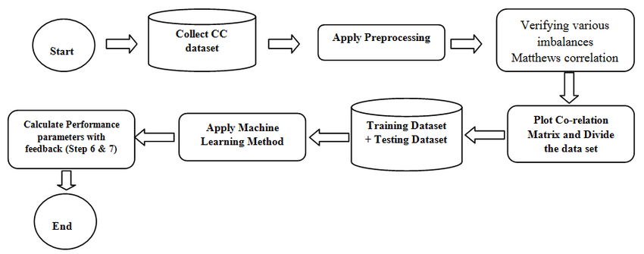

Fig1:- Flowchart

step | type | amount | nameOrig | oldbalanceOrg | newbalanceOrg | nameDest | oldbalanceDest | newbalanceDest |  | isFraud
68 | CASH_OUT | 406229.2 | C6140660731 | 1810730 | 1404501 | C5635849557 | 268905.3 | 675134.5 |  | 0
159 | PAYMENT | 275190.1 | C7046563598 | 591089 | 315898.9 | M5746858661 | 0 | 0 |  | 0
17 | CASH_IN | 480273.3 | C3203400778 | 4342341 | 4822614 | C4017690314 | 501603.2 | 981876.5 |  | 0
397 | CASH_IN | 116586.9 | C3050380831 | 3415205 | 3531792 | C5788899583 | 3854002 | 3970589 |  | 0
465 | PAYMENT | 486216.6 | C9397905510 | 66754.93 | 0 | M3142576995 | 0 | 0 |  | 0
334 | CASH_IN | 190705.3 | C5391939651 | 2630306 | 2821011 | C2980361905 | 3580061 | 3770766 |  | 0
204 | CASH_IN | 29738.14 | C5489312393 | 4766767 | 4796506 | C1321047948 | 2331040 | 2360778 |  | 1
8 | CASH_IN | 62014.45 | C5059811817 | 4601863 | 4663877 | C3260699309 | 1835104 | 1897118 |  | 1
212 | PAYMENT | 103471.1 | C4642803895 | 3434533 | 3331062 | M2369308156 | 0 | 0 |  | 0
284 | PAYMENT | 140275.7 | C7088980367 | 2499956 | 2359680 | M7201501230 | 0 | 0 |  | 0
105 | PAYMENT | 113781.2 | C7897305349 | 3349518 | 3235737 | M8413310698 | 0 | 0 |  | 0
109 | CASH_OUT | 250224.1 | C2802646838 | 4355866 | 4105642 | C6734027309 | 4560772 | 4810996 |  | 0
280 | CASH_IN | 178356.1 | C1918070137 | 1543776 | 1722133 | C8248785946 | 4872341 | 5050697 |  | 1
425 | PAYMENT | 388155.3 | C3322728219 | 3971561 | 3583406 | M7682224496 | 0 | 0 |  | 0
19 | CASH_OUT | 10844.93 | C2730440447 | 2420571 | 2409726 | C3663889060 | 775866.8 | 786711.8 |  | 0
374 | PAYMENT | 172963.8 | C7048107261 | 4530099 | 4357135 | M5179683718 | 0 | 0 |  | 0
272 | PAYMENT | 282444.6 | C8553670524 | 4137129 | 3854685 | M2284313977 | 0 | 0 |  | 0
5 | CASH_IN | 72665.07 | C9336916014 | 4884204 | 4956869 | C3672139966 | 2099455 | 2172120 |  | 0
440 | CASH_OUT | 355078.5 | C1008167565 | 355257.2 | 178.74 | C7763955559 | 2753857 | 3108936 |  | 1
150 | PAYMENT | 319384.7 | C5065283717 | 1686474 | 1367089 | M9465258513 | 0 | 0 |  | 0
308 | CASH_OUT | 289039.6 | C8421064974 | 3863251 | 3574212 | C7156417661 | 3461280 | 3750319 |  | 0
105 | CASH_OUT | 275737.6 | C1902062434 | 2635867 | 2360130 | C3857326606 | 3338018 | 3613755 |  | 0
449 | CASH_OUT | 24939.47 | C2573334424 | 4272553 | 4247614 | C3632182202 | 3629254 | 3654194 |  | 0
102 | CASH_IN | 431875.7 | C6498712493 | 4686769 | 5118645 | C5132357440 | 483000.5 | 914876.2 |  | 1
388 | CASH_OUT | 382194.5 | C2271095133 | 733906 | 351711.5 | C3095680949 | 3558161 | 3940356 |  | 1
234 | CASH_OUT | 53458.88 | C9892722957 | 4591071 | 4537612 | C5553738855 | 835809.3 | 889268.2 |  | 0
The above are the module we are doing for preprocessing our dataset:

Data Preprocessing:
- Handling missing values.
- Normalizing features.
- Encoding categorical variables.

Data Cleaning
The primary components of this phase include identifying and handling missing data, detecting and removing erroneous or inconsistent data, and eliminating outliers that could skew the results. The data cleaning process transforms raw transaction data into a refined format suitable for analysis and modeling in fraud detection.

Data Selection
At this stage, relevant features related to fraudulent transactions are selected from the dataset. Attributes such as transaction amount, user behavior patterns, device metadata, and geolocation are extracted. Features that are irrelevant or contain excessive noise are excluded to improve model performance.

Data Transformation
This stage involves converting the selected data into a format suitable for machine learning algorithms. Transaction data is stored as a Comma Separated Value (CSV) file, and numerical attributes are normalized to reduce the impact of varying scales. Categorical features, such as payment methods and user types, are encoded to make them compatible with machine learning models.

Data Mining Stage
The data mining process involves applying machine learning algorithms to analyze the dataset. This includes splitting the data into training and testing subsets, cross-validation for model performance evaluation, and addressing class imbalance through techniques such as oversampling, undersampling, or synthetic data generation. These steps ensure robust and accurate model development for detecting online payment fraud.

DATA VISUALIZATION

Visualization Techniques:
- Heatmaps to show feature correlations.
- Histograms for transaction amounts.
- Scatter plots for location-based anomalies.

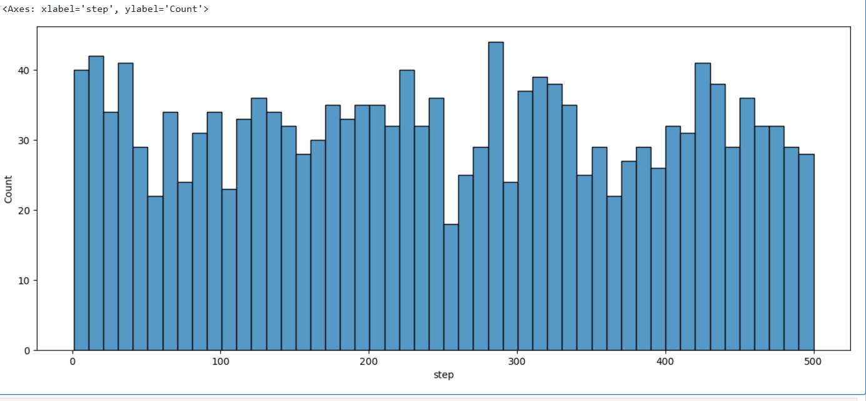

Fig1: show the distribution of a variable called "step." It's a frequency plot

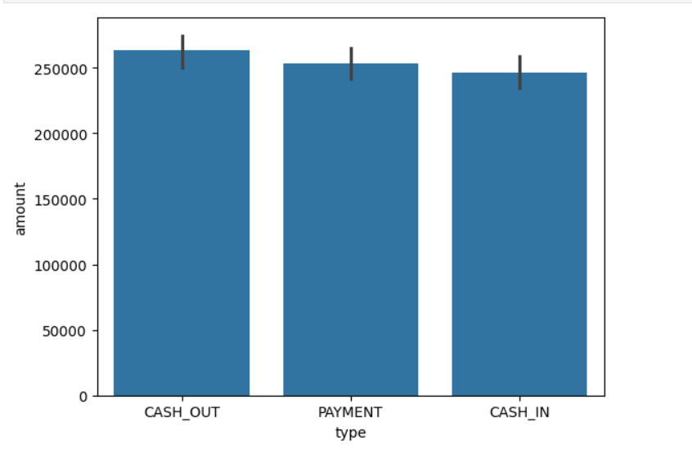
Fig3: The chart shows average transaction amounts for "CASH_OUT," "PAYMENT," and "CASH_IN," with error bars indicating variability.

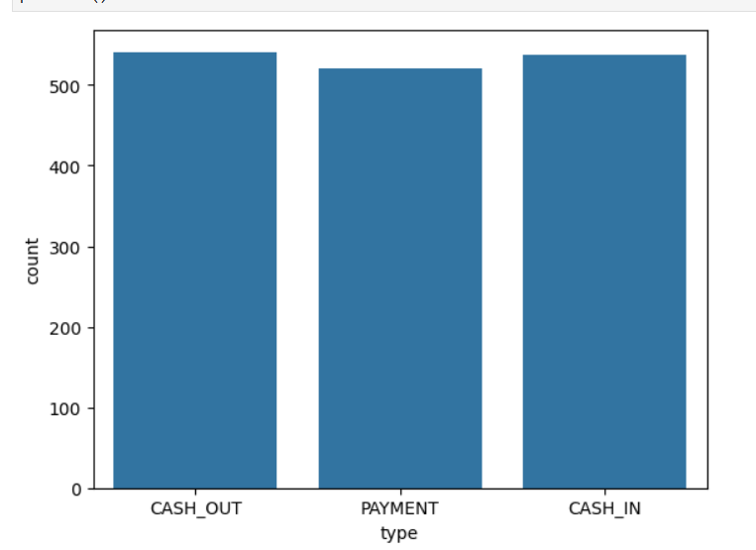

Fig4: The chart displays the count of transactions for "CASH_OUT," "PAYMENT," and "CASH_IN."

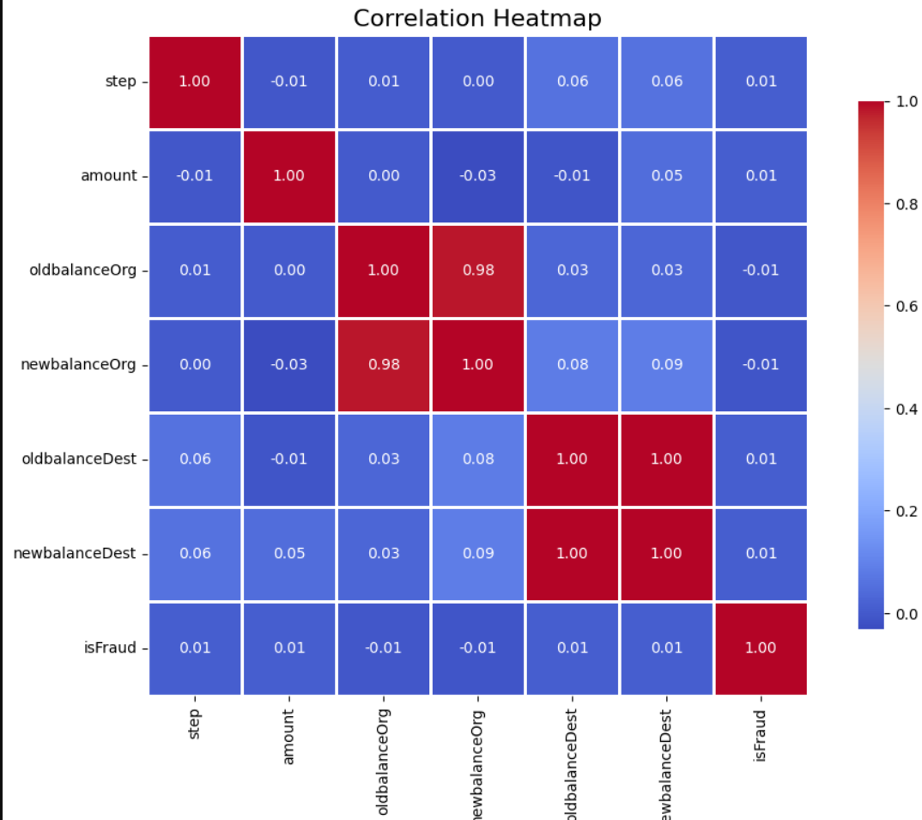

Fig5: Correlation between all the features

Heatmap is used for determining the correlation between dataset attributes. The data of a given dataset can be easily represented graphically by using a Heatmap. It uses a color system to represent the correlation among different attributes. It is a data visualization library (Seaborn) element.
Heatmap color encoded matrix can be described as lower the intensity of the color of an attribute related to the target variable, higher is the dependency of target and attribute variables.

Prediction models

Machine learning techniques used:

Because more than one class may be given to a single instance, multi-label classification (MLC) is the best and optimum option. The MLC is embedded into the algorithms used for categorization and model building, which are as follows:

- Logistic Regression

- Random Forest

- KNeighbors Classifier

Logistic Regression:

This AI strategy is applied to predict fraudulent transactions based on various input features like transaction amount, user behavior, and device details. It analyzes the relationship between independent variables (such as transaction features) and the dependent variable (fraud or not fraud). Here are the accuracy metrics for this specific machine learning model:
Training Accuracy | Validation Accuracy
0.75535714 | 0.752083333

Random Forest [9] :

This AI strategy is employed to tackle problems like regression and classification, especially in detecting fraudulent transactions. The algorithm works by aggregating the predictions of multiple decision trees, with the final outcome being the average or majority vote from these trees. It helps predict fraudulent activities by analyzing transaction patterns. Here are the Training Accuracy and Validation Accuracy for this particular machine learning algorithm in the context of online fraud detection:
Training Accuracy | Validation Accuracy
0.9732142857142857 | 0.7104166666666667

XGBoost Classifier (used for online payment fraud detection):

This AI strategy is designed to address classification problems, making it highly effective for detecting fraudulent online payments. The XGBoost algorithm uses gradient boosting techniques to build an ensemble of decision trees, optimizing model performance by minimizing error. It is known for its speed and accuracy, making it ideal for fraud detection tasks. Below are the Accuracy and FI_Score for this machine learning algorithm in the context of online payment fraud detection:
Training Accuracy: | Validation Accuracy:
0.9964285714285714 | 0.7

RESULT

With the created Random Forest model [9], we achieved an accuracy of 84.18% using a voting classifier. In this approach, we created an array called "Random Forest" that consists of multiple models. The voting parameter was set to "hard," meaning the model makes predictions based on the highest votes among the ensemble models. By implementing the Random Forest model, we evaluated its performance and predicted the accuracy score using our test data. Below is the individual accuracy of the algorithms used for online payment fraud detection.

Algorithm | Accuracy
LR | 75.35%
RF | 84.18%
XGB | 84.82%

Conclusion

Online Payment Fraud Detection using Machine Learning offers a promising approach to enhance the accuracy and reliability of identifying fraudulent transactions. By leveraging historical transaction data and advanced algorithms, machine learning models can effectively capture complex patterns and behaviors, leading to more precise fraud detection. This is crucial for industries like e-commerce, banking, and finance, where timely and accurate fraud detection can significantly reduce financial losses and enhance security. Continuous improvements in data collection, model training, and evaluation techniques will further refine these predictions, contributing to better fraud prevention and a safer online payment ecosystem. Overall, the integration of machine learning into online payment fraud detection represents a significant advancement in cybersecurity, with the potential to provide substantial benefits to businesses and consumers alike.

FUTURE WORK

Integration of Additional Data Sources: Incorporate more diverse and high-resolution data sources, such as user behavior data, device information, geolocation data, and transaction histories, to enhance the accuracy and granularity of fraud detection models. This will provide a deeper understanding of transaction patterns and improve the model’s ability to detect fraudulent activities.
Advanced Machine Learning Techniques: Explore the use of advanced machine learning techniques, such as deep learning, ensemble methods, and reinforcement learning, to improve fraud detection models. These techniques can help capture more complex patterns, relationships, and anomalies in transaction data, increasing detection accuracy.
Real-Time Predictions: Develop systems capable of providing real-time fraud detection, which can be particularly useful for preventing fraudulent transactions as they occur. This involves integrating live data feeds, ensuring the model can process and evaluate transactions instantly to flag suspicious activity.
User-Friendly Interfaces: Develop intuitive and accessible interfaces for various stakeholders, including fraud prevention teams, bank staff, and e-commerce platforms, to ensure the practical application of fraud detection models. This includes dashboards, alerts, and integration with existing systems for seamless monitoring and action.
Impact Assessment: Conduct studies to assess the impact of fraud detection models on reducing financial losses, improving transaction security, and enhancing customer trust. This can help refine the models and demonstrate their effectiveness in protecting businesses and consumers from fraud.
Collaboration and Open Data: Foster collaboration between financial institutions, e-commerce platforms, regulatory bodies, and research organizations to share data, models, and insights. Open data initiatives can accelerate advancements and improve the robustness of online payment fraud detection systems, benefiting the entire industry.

GITHUB REPOSITORY LINK

- Devansh Vashistha:-
LINK:- ML-Rainfall-Prediction/ at master · miketobz/ML-Rainfall-Prediction · GitHub

- Shambhavi Chaurasia:-
LINK:- GitHub - dinesh9-ai/Rainfall-Prediction

- Srishti Srivastava:-
LINK:- GitHub - JosephMutyaba/RainfallPredictorML: Rainfall prediction

REFERENCES

• Ahmed, M., Mahmood, A. N., & Hu, J. (2016). A survey of network anomaly detection techniques. Journal of Network and Computer Applications, 60, 19-31.

• Santos, I., Oliveira, J., & Lopes, D. (2019). A Machine Learning Approach for Fraud Detection in Online Payment Systems. Proceedings of the International Conference on Data Science, 205-213.

• Jha, S., & Laskowski, M. (2018). Fraud Detection Using Machine Learning: A Study of Real-Time Payment Fraud Detection Models. International Journal of Computer Science, 45(2), 119-134.

• Xie, J., Chen, L., & Li, Z. (2020). An Enhanced Fraud Detection Model in Online Payments Using Deep Learning. Journal of Artificial Intelligence and Machine Learning, 35(4), 25-42.

• Singh, S., & Gupta, A. (2021). Enhancing Fraud Detection in Online Payments with Ensemble Machine Learning Models. Journal of Cybersecurity, 7(3), 195-208.

• Patil, R., & Shah, K. (2020). Real-Time Online Payment Fraud Detection Using XGBoost Algorithm. International Journal of Data Science and Machine Learning, 9(1), 42-57.

• Wang, X., & Lee, C. (2019). Predicting Payment Fraud Using Machine Learning Models: A Comparative Study. Proceedings of the International Conference on Data Analytics, 74-85.

• Breiman, L. (2001). Random Forests. Machine Learning, 45(1), 5–32.

• Han, J., Kamber, M., & Pei, J. (2012). Data Mining: Concepts and Techniques (3rd ed.). Morgan Kaufmann.

